Task 4 - Choosing a Map for a pharmacy inventory 1.Design reasoning (before implementation)
Map | put / get | Iteration | Natural order | Extra work for the report it does NOT give
HashMap | O(1) average | O(n + capacity), unordered | None | Code-order report: copy values and sort, O(n log n). Added-order report: keep a separate list.
TreeMap | O(log n) (red-black tree) | O(n), sorted by key | Code order (Report A) | Added-order report: keep a separate ArrayList of medicines (extra O(n) memory) or store a sequence number and sort.
LinkedHashMap | O(1) average | O(n), in insertion order | Added order (Report B) | Code-order report: copy values and sort, O(n log n).

Test data: Medicine(code, name, stock), codes like MED0000123 inserted in shuffled order, so insertion order and code order are genuinely different. Sizes: 1,000, 10,000 and 100,000 medicines; 100,000 random lookups; each timing is an average of 5 runs after warm-up.

2. Code
import java.util.*;

/**
* Q4 - HashMap vs TreeMap vs LinkedHashMap for a pharmacy inventory (+ sorted array with binarySearch)
* Run: java Q4_PharmacyMaps.java
*/
public class Q4_PharmacyMaps {

static class Medicine {
final String code; final String name; int stock;
Medicine(String code, String name, int stock) { this.code = code; this.name = name; this.stock = stock; }
}

static final int LOOKUPS = 100_000;
static final int REPEAT = 5;
static long sink = 0;

interface Task { void run(); }
static double time(Task t) {
for (int w = 0; w < 2; w++) t.run();
double tot = 0;
for (int r = 0; r < REPEAT; r++) { long t0 = System.nanoTime(); t.run(); tot += (System.nanoTime() - t0) / 1e6; }
return tot / REPEAT;
}

// codes are added in RANDOM order, so "insertion order" and "code order" are genuinely different
static List<Medicine> makeMedicines(int n) {
List<Medicine> list = new ArrayList<>();
for (int i = 0; i < n; i++) list.add(new Medicine(String.format("MED%07d", i), "Drug" + i, i % 500));
Collections.shuffle(list, new Random(42));
return list;
}

static boolean sortedByCode(Collection<Medicine> c) {
String prev = "";
for (Medicine m : c) { if (m.code.compareTo(prev) < 0) return false; prev = m.code; }
return true;
}

public static void main(String[] args) {
int[] sizes = {1_000, 10_000, 100_000};
for (int n : sizes) {
List<Medicine> meds = makeMedicines(n);
String[] queries = new String[LOOKUPS];
Random rnd = new Random(5);
for (int i = 0; i < LOOKUPS; i++) queries[i] = meds.get(rnd.nextInt(n)).code;

Map<String, Medicine> hm = new HashMap<>(), tm = new TreeMap<>(), lhm = new LinkedHashMap<>();
System.out.println("\n================ N = " + n + " medicines ================");
System.out.printf("%-14s %12s %16s %22s %22s%n", "Map", "put all (ms)", "100k lookups(ms)",
"Report A: code order", "Report B: added order");

List<Map<String, Medicine>> maps = Arrays.asList(hm, tm, lhm);
String[] names = {"HashMap", "TreeMap", "LinkedHashMap"};
for (int k = 0; k < 3; k++) {
final Map<String, Medicine> m = maps.get(k);
final String name = names[k];
double put = time(() -> {
Map<String, Medicine> fresh = name.equals("HashMap") ? new HashMap<>()
: name.equals("TreeMap") ? new TreeMap<>() : new LinkedHashMap<>();
for (Medicine x : meds) fresh.put(x.code, x);
});
for (Medicine x : meds) m.put(x.code, x); // the map used for lookups/reports
double get = time(() -> { for (String q : queries) sink += m.get(q).stock; });

// Report A: all medicines in code order
double repA = time(() -> {
Collection<Medicine> out;
if (m instanceof TreeMap) out = m.values(); // already sorted
else { List<Medicine> l = new ArrayList<>(m.values()); // extra work: sort
l.sort(Comparator.comparing(x -> x.code)); out = l; }
for (Medicine x : out) sink += x.stock;
});
// Report B: medicines in the order they were added
double repB = time(() -> {
Collection<Medicine> out;
if (m instanceof LinkedHashMap) out = m.values(); // already in order
else out = meds; // extra structure needed: keep a separate list
for (Medicine x : out) sink += x.stock;
});
// order checks
Collection<Medicine> a = (m instanceof TreeMap) ? m.values() : sortedCopy(m.values());
boolean okA = sortedByCode(a);
boolean okB = (m instanceof LinkedHashMap) && sameOrder(m.values(), meds);
String bText = (m instanceof LinkedHashMap) ? (okB ? "matches (native)" : "WRONG")
: "needs extra list";
System.out.printf("%-14s %12.2f %16.2f %14.2f (%s) %14.2f (%s)%n", name, put, get,
repA, (m instanceof TreeMap ? "native" : "sorted") + (okA ? " ok" : " BAD"),
repB, bText);
}

// ---- Alternative: sorted array + Arrays.binarySearch ----
Medicine[] arr = meds.toArray(new Medicine[0]);
Arrays.sort(arr, Comparator.comparing(x -> x.code));
String[] keys = new String[n];
for (int i = 0; i < n; i++) keys[i] = arr[i].code;
double bs = time(() -> { for (String q : queries) sink += Arrays.binarySearch(keys, q); });
double ins = time(() -> { // insert 200 new codes into the sorted arrays (shifting needed)
String[] kk = Arrays.copyOf(keys, n + 200);
int size = n;
for (int i = 0; i < 200; i++) {
String code = String.format("MED9%06d", i);
int pos = -Arrays.binarySearch(kk, 0, size, code) - 1;
System.arraycopy(kk, pos, kk, pos + 1, size - pos); // O(n) shift
kk[pos] = code; size++;
}
sink += size;
});
System.out.printf("Sorted array + binarySearch: 100k lookups = %.2f ms ; 200 insertions = %.2f ms ; code-order report = already sorted%n", bs, ins);
}
System.out.println("(ignore) sink=" + sink);
}

static List<Medicine> sortedCopy(Collection<Medicine> c) {
List<Medicine> l = new ArrayList<>(c); l.sort(Comparator.comparing(x -> x.code)); return l;
}
static boolean sameOrder(Collection<Medicine> c, List<Medicine> ref) {
Iterator<Medicine> it = c.iterator();
for (Medicine m : ref) if (!it.hasNext() || it.next() != m) return false;
return true;
}
}

3. Output
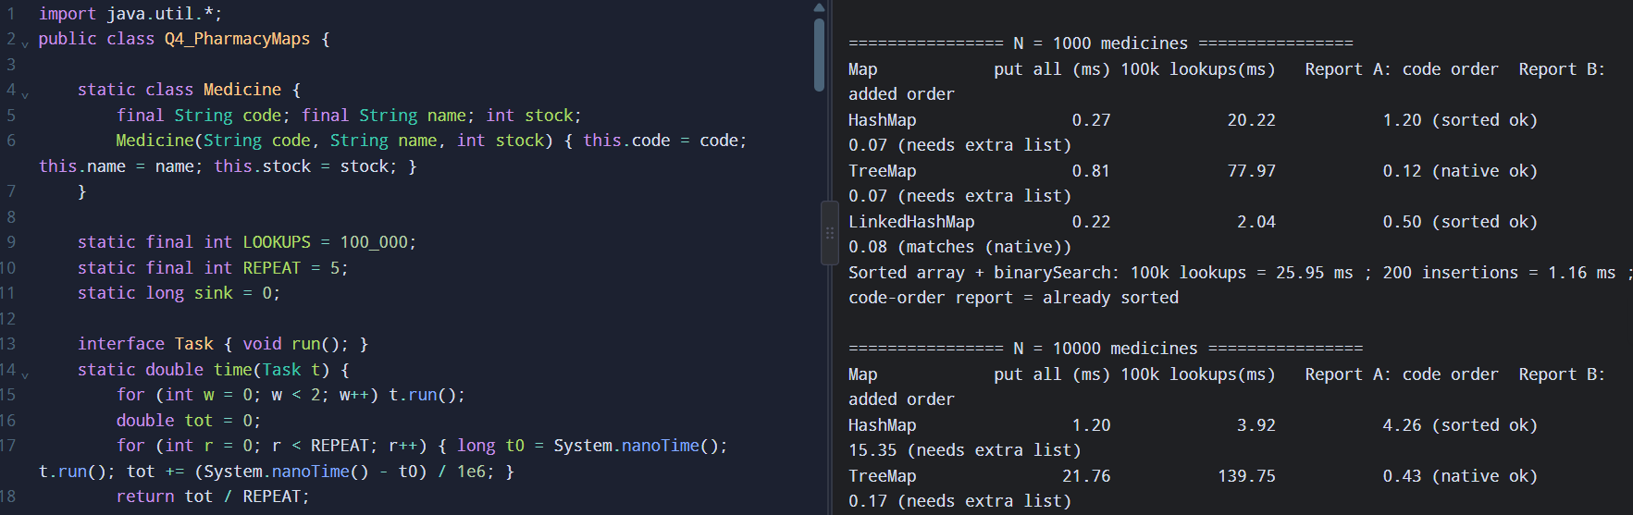

"native" = the map already produced that order; "sorted" = I had to copy and sort; "needs extra list" = the map cannot give insertion order, so a separate list is required. The program checks the order programmatically (ok/matches).

4. Scalability inquiry - answers
- Acceptable response time (my definition): one lookup must complete in under 1 millisecond, so it never delays a pharmacist (people notice delays above about 100 ms, and the lookup is only one part of the screen response). Pharmacists do hundreds of lookups a day, so even 1 ms would be generous.
- Evidence: at 100,000 medicines, 100,000 lookups took about 4 ms (HashMap, LinkedHashMap) and about 65 ms (TreeMap), i.e. 0.04 microsecond to 0.65 microsecond per lookup. All three pass by a huge margin; sorted-array binary search (about 98 ms per 100,000 lookups) also passes.
- Deployment choice: LinkedHashMap. It gives the fastest lookups (O(1)) and the added-order report with no extra work. The evening code-order report costs one sort (about 70 ms at 100,000 medicines, once a day - irrelevant). TreeMap would be equally defensible if the code-order report were the main requirement; its lookups are about 12-18x slower than the hash maps but still under a microsecond each.
- Where the remaining cost comes from: computing String.hashCode() / equals() (or compareTo() about 17 times in a TreeMap), chasing object references (cache misses), and for the report the O(n log n) sort. The Map structure itself is no longer the bottleneck.
- Why Hashtable is not preferred in new code: it is a legacy class; every method is synchronized on one lock, so threads block each other and it is slower even single-threaded; it forbids null keys and values; and it gives no ordering. Use HashMap (single thread) or ConcurrentHashMap (multi-thread) instead.

5. Alternative concept and complexity analysis
Sorted array + `Arrays.binarySearch()`: keep Medicine[] (or a parallel String[] of codes) sorted by code. Lookup = Arrays.binarySearch(keys, code). Insert = binary search for the position, then System.arraycopy to shift (the program measures this). The code-order report is just a loop over the array.
Operation | Sorted array + binarySearch | HashMap | TreeMap
Lookup | O(log n) | O(1) average | O(log n)
Insert a new medicine | O(n) (shift elements; O(log n) to find the position) | O(1) average | O(log n)
Code-order report | O(n) (already sorted) | O(n log n) (sort needed) | O(n)
Space | O(n), the most compact: one reference per element, no node objects | O(n): about 32 bytes per entry + table | O(n): about 40 bytes per node

Conclusion: the sorted array is excellent for read-mostly data (compact, fast sorted report) but insertion is O(n); because stock changes and new medicines are added, a map is the better engineering choice.

